**| zet Ori |**

|  |  |
| --- | --- |
| **Luminosity** *in Solar Luminosity* | $$250 000 L_{☉}$$ |
| **Surface Temperature** *in Kelvin* | $$29 500 K$$ |
| **Spectral Class** | $$O$$ |
| **Mass** *in Solar Mass* | $$33 M_{☉}$$ |
| **Radius** *in Solar Radius* | $$20 R_{☉}$$ |
| **Distance** *in Lightyears* | $$1 260 Ly$$ |

Alnitak is a triple star system and the eastern star of the Orion belt. The main star Alnitak A is a luminous supergiant with 10 000 times the luminosity of the Sun in the visible range. Seen from Earth it is the brightest star of its spectral class.

***Blue Supergiant***

**Alnitak A**

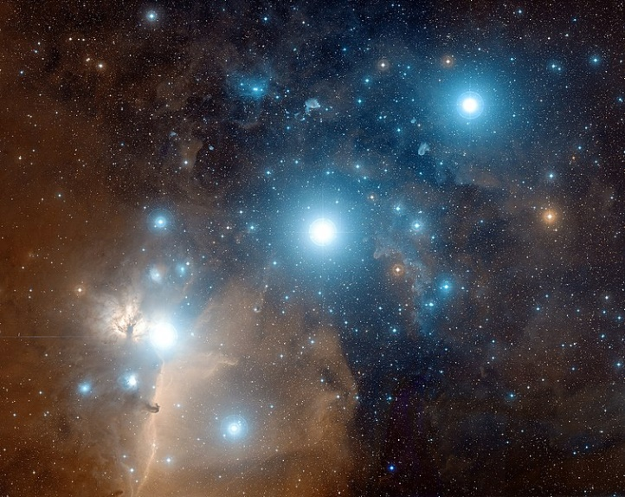

*Alnitak (bright star lower left), right next to the Flame Nebula*

**| zet Pup |**

|  |  |
| --- | --- |
| **Luminosity** *in Solar Luminosity* | $$800 000 L_{☉}$$ |
| **Surface Temperature** *in Kelvin* | $$42 500 K$$ |
| **Spectral Class** | $$O$$ |
| **Mass** *in Solar Mass* | $$56 M_{☉}$$ |
| **Radius** *in Solar Radius* | $$20 R_{☉}$$ |
| **Distance** *in Lightyears* | $$1090 Ly$$ |

Zeta Puppis is a blue supergiant and thus one of the hottest and brightest stars in the Milky Way. It is a runaway star, meaning it has a very large pace velocity compared to its surrounding stellar medium. This is probably because Zeta Puppis was ejected from a close binary system when its companion exploded as a supernova.

***Blue Supergiant***

**Zeta Puppis**

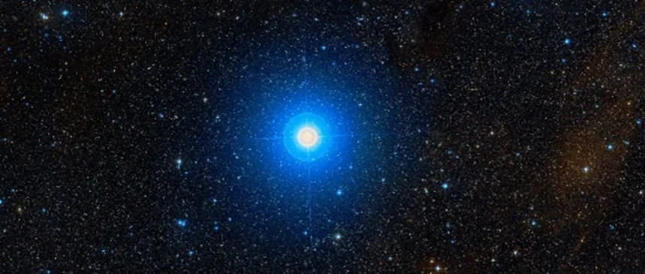

*Close up of Zeta Puppis*

**| alf Vir |**

|  |  |
| --- | --- |
| **Luminosity** *in Solar Luminosity* | $$20 500 L_{☉}$$ |
| **Surface Temperature** *in Kelvin* | $$25 300 K$$ |
| **Spectral Class** | $$B$$ |
| **Mass** *in Solar Mass* | $$11,4 M_{☉}$$ |
| **Radius** *in Solar Radius* | $$7,5 R_{☉}$$ |
| **Distance** *in Lightyears* | $$250 Ly$$ |

Spica is a rotating ellipsoidal variable, i.e. a close binary system in which the stars are distorted by their gravitational interaction. The effect provides a periodically fluctuating apparent magnitude. The primary star is at the end of its stable lifetime and will eventually end as a supernova.

***Blue Giant*Spica**

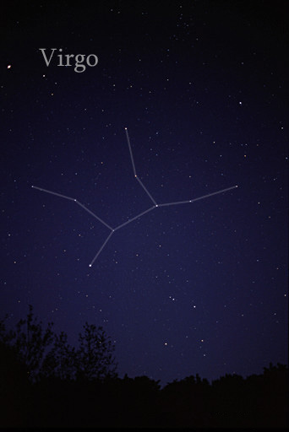

*Spica, the brightest star in the constellation Virgo (lower left)*

**| gam Ori |**

|  |  |
| --- | --- |
| **Luminosity** *in Solar Luminosity* | $$4 000 L_{☉}$$ |
| **Surface Temperature** *in Kelvin* | $$22 000 K$$ |
| **Spectral Class** | $$B$$ |
| **Mass** *in Solar Mass* | $$8 M_{☉}$$ |
| **Radius** *in Solar Radius* | $$5,4 R_{☉}$$ |
| **Distance** *in Lightyears* | $$252 Ly$$ |

Bellatrix is the right shoulder of Orion and the third brightest star of the constellation. It is a giant star which will blow up in about 100 million years and end up as a White Dwarf. Bellatrix has been used as a spectral standard star until it was found to have a variable magnitude.

***Blue Giant*Bellatrix**

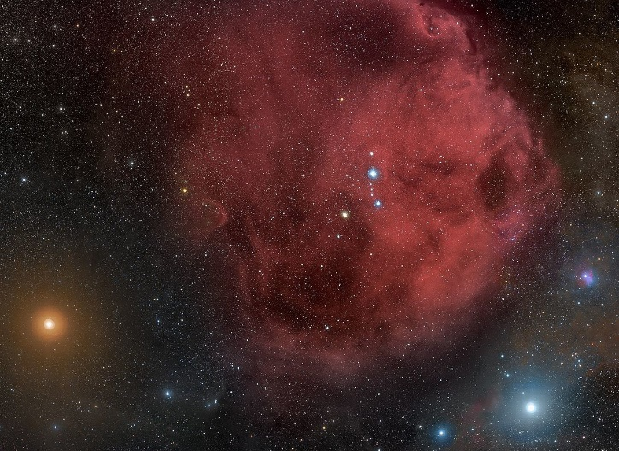

*Bellatrix (lower right) in front of an emission nebula*

**| alf Eri |**

|  |  |
| --- | --- |
| **Luminosity** *in Solar Luminosity* | $$3 000 L_{☉}$$ |
| **Surface Temperature** *in Kelvin* | $$18 700 K$$ |
| **Spectral Class** | $$B$$ |
| **Mass** *in Solar Mass* | $$7 M_{☉}$$ |
| **Radius** *in Solar Radius* | $$7,5 R_{☉}$$ |
| **Distance** *in Lightyears* | $$139 Ly$$ |

Achernar is the ninth brightest star in the sky. Since it is far south, it is not visible from the northern hemisphere. Achernar has a very high rotation speed of at least 230 km/s, which is why it is strongly oblate (the equatorial diameter is twice the distance of the poles).

***Main-Sequence Star*Achernar**



*An illustration of Achernar, flattened by its extreme rotation speed*

**| eta UMa |**

|  |  |
| --- | --- |
| **Luminosity** *in Solar Luminosity* | $$463 L_{☉}$$ |
| **Surface Temperature** *in Kelvin* | $$15 700 K$$ |
| **Spectral Class** | $$B$$ |
| **Mass** *in Solar Mass* | $$6,1 M_{☉}$$ |
| **Radius** *in Solar Radius* | $$3.9 R_{☉}$$ |
| **Distance** *in Lightyears* | $$104 Ly$$ |

Alkaid is a star in the constellation of Ursa Major and the most eastern of the big dipper. It rotates unusually fast, so it is slightly flattened. It also shows minor brightness variations in a period of about 3 days.

***Main-Sequence Star*Alkaid**

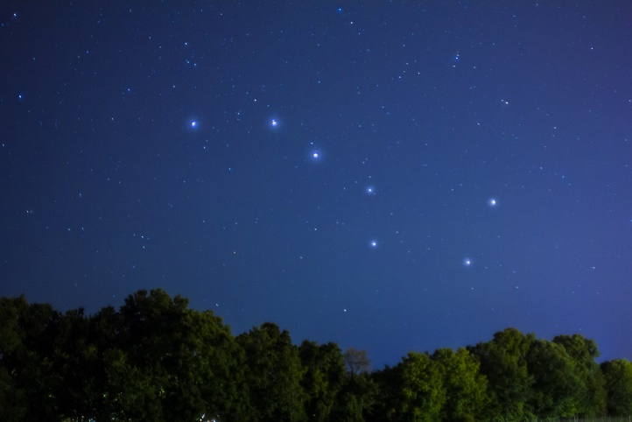

*Alkaid is the drawbar star of the Big Dipper (top left)*

**| bet Ori |**

|  |  |
| --- | --- |
| **Luminosity** *in Solar Luminosity* | $$40 600 L_{☉}$$ |
| **Surface Temperature** *in Kelvin* | $$12 300 K$$ |
| **Spectral Class** | $$B$$ |
| **Mass** *in Solar Mass* | $$17 M_{☉}$$ |
| **Radius** *in Solar Radius* | $$62 R_{☉}$$ |
| **Distance** *in Lightyears* | $$770 Ly$$ |

Rigel is the brightest star of Orion and shines strikingly white. It played an important role in ancient Egyptian mythology. There it was the main star of the constellation Sah, which was composed of parts of Orion and Taurus.

***Blue Giant*Rigel**

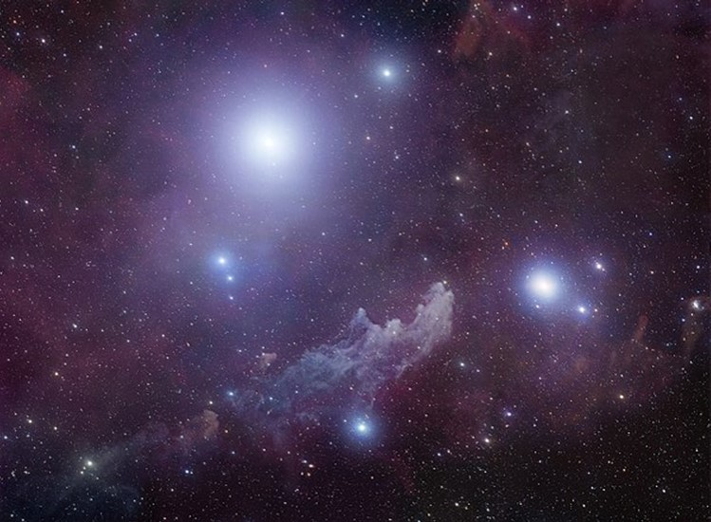

*Rigel (brightest star) in front of the reflection nebula IC 2118*

**| omi02 Eri |**

|  |  |
| --- | --- |
| **Luminosity** *in Solar Luminosity* | $$0,01 L_{☉}$$ |
| **Surface Temperature** *in Kelvin* | $$167 00 K$$ |
| **Spectral Class** | $$A$$ |
| **Mass** *in Solar Mass* | $$0,6 M_{☉}$$ |
| **Radius** *in Solar Radius* |  |
| **Distance** *in Lightyears* |  |

Eridani is a triple star system 16 light years away. The main star Eridani A is very similar to the Sun in size and age. The second star Eridani B is the first dwarf star discovered (already in 1783). Eridani C is a tiny but highly active star with fluctuating brightness.

***White Dwarf*40 Eridani B**

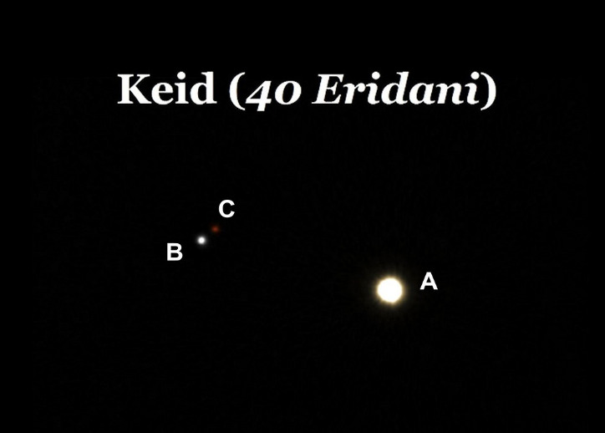

*Telescope image from 40 Eridani A, B & C*

**| alf CMa |**

|  |  |
| --- | --- |
| **Luminosity** *in Solar Luminosity* | $$25,4 L_{☉}$$ |
| **Surface Temperature** *in Kelvin* | $$9 900 K$$ |
| **Spectral Class** | $$A$$ |
| **Mass** *in Solar Mass* | $$2,1 M_{☉}$$ |
| **Radius** *in Solar Radius* | $$1,7 R_{☉}$$ |
| **Distance** *in Lightyears* | $$8,6 Ly$$ |

Sirius is a binary star system with a very faint companion. It is also called Dog Star. Sirius A is the brightest star in the night sky, being one of the nearest stars at only 8.6 Ly.

***Main-Sequence Star*Sirius A**

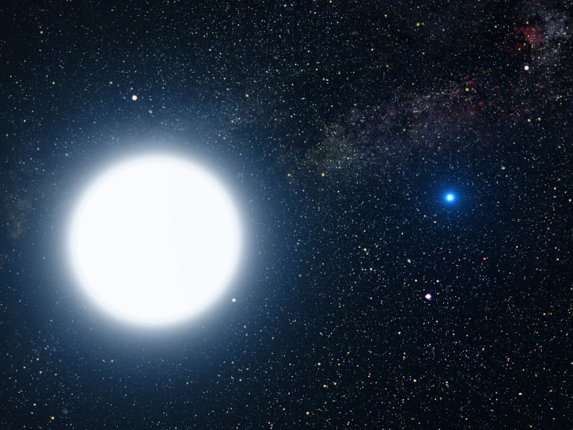

*Sirius A with its dim companion*

**| alf Lyr |**

|  |  |
| --- | --- |
| **Luminosity** *in Solar Luminosity* | $$37 L_{☉}$$ |
| **Surface Temperature** *in Kelvin* | $$9 600 K$$ |
| **Spectral Class** | $$A$$ |
| **Mass** *in Solar Mass* | $$2,2 M_{☉}$$ |
| **Radius** *in Solar Radius* | $$2,7 R_{☉}$$ |
| **Distance** *in Lightyears* | $$25 Ly$$ |

With its white light Vega is the second brightest star of the northern sky. This is not due to its absolute magnitude, but rather to its very short distance of only 25 Ly. In former times Vega served as a reference star for brightness measurements.

***Main-Sequence Star*Vega**

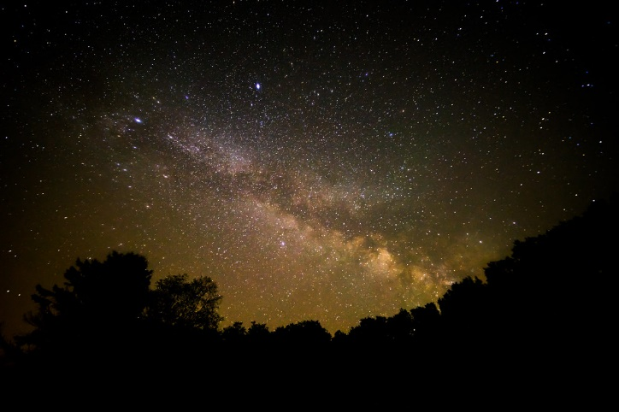

*The Vega above the Milky Way*

**| alf Cyg |**

|  |  |
| --- | --- |
| **Luminosity** *in Solar Luminosity* | $$196 000 L_{☉}$$ |
| **Surface Temperature** *in Kelvin* | $$8 700 K$$ |
| **Spectral Class** | $$A$$ |
| **Mass** *in Solar Mass* | $$22,5 M_{☉}$$ |
| **Radius** *in Solar Radius* | $$150 R_{☉}$$ |
| **Distance** *in Lightyears* | $$1 411 Ly$$ |

Deneb is the brightest known star of the Milky Way (absolute magnitude). Due to its enormous luminosity, it is easily visible in the night sky even with the naked eye, despite its very high distance.

***Blue Supergiant***

**Deneb**

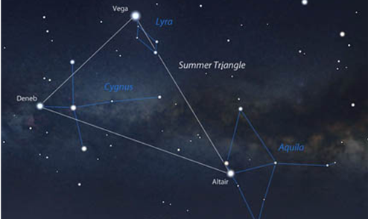

*Stellarium image of the Summer Triangle*

**| alf CMi |**

|  |  |
| --- | --- |
| **Luminosity** *in Solar Luminosity* | $$0,0005 L_{☉}$$ |
| **Surface Temperature** *in Kelvin* | $$7 740 K$$ |
| **Spectral Class** |  |
| **Mass** *in Solar Mass* |  |
| **Radius** *in Solar Radius* |  |
| **Distance** *in Lightyears* |  |

Procyron is a binary star system in the constellation Canis Minor and with only 11.4 Ly distance one of the closest star systems. Procyron A is a whitish-yellowish, sun-like star, easily visible to the naked eye. It is accompanied by a faint white dwarf, Procyron B.

***White Dwarf*Procyron B**

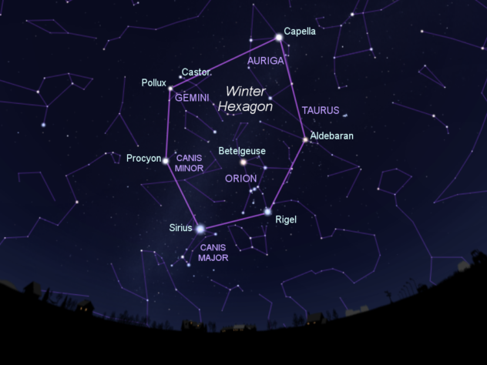

*Procyron is one of the stars of the winter hexagon (in the Canis Minor)*

**| alf Aql |**

|  |  |
| --- | --- |
| **Luminosity** *in Solar Luminosity* | $$10,6 L_{☉}$$ |
| **Surface Temperature** *in Kelvin* | $$7 550 K$$ |
| **Spectral Class** | $$A$$ |
| **Mass** *in Solar Mass* | $$1,7 M_{☉}$$ |
| **Radius** *in Solar Radius* | $$1,8 R_{☉}$$ |
| **Distance** *in Lightyears* | $$16,7 Ly$$ |

Altair is one of the brightest stars visible from the northern hemisphere. Altair rotates very fast around its axis and is therefore strongly flattened. It needs only 10 hours for one rotation (sun needs 25 days). Altair is a very young star but will become a red giant in about 1 billion years.

***Main-Sequence Star*Altair**

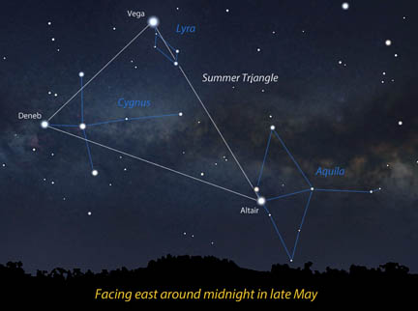

*Stellarium image of the Summer Triangle*

**| alf CMi |**

|  |  |
| --- | --- |
| **Luminosity** *in Solar Luminosity* | $$6,9 L_{☉}$$ |
| **Surface Temperature** *in Kelvin* | $$6 530 K$$ |
| **Spectral Class** |  |
| **Mass** *in Solar Mass* |  |
| **Radius** *in Solar Radius* |  |
| **Distance** *in Lightyears* |  |

Procyron is a binary star system in the constellation Canis Minor and with "only" 11.4 Ly distance one of the closest star systems. Procyron A is a whitish-yellowish, sun-like star, easily visible to the naked eye. It is accompanied by a faint white dwarf, Procyron B.

***Main-Sequence Star*Procyron A**

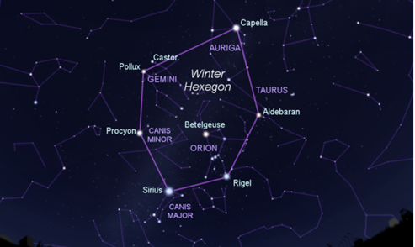

*Procyron is one of the stars of the winter hexagon (in the Canis Minor)*

**| Wolf 28 |**

|  |  |
| --- | --- |
| **Luminosity** *in Solar Luminosity* | $$0,0002 L_{☉}$$ |
| **Surface Temperature** *in Kelvin* | $$6 200 K$$ |
| **Spectral Class** | $$F$$ |
| **Mass** *in Solar Mass* | $$0,7 M_{☉}$$ |
| **Radius** *in Solar Radius* | $$0,01 R_{☉}$$ |
| **Distance** *in Lightyears* | $$14,1 Ly$$ |

Van Maanen 2 is the nearest known white dwarf and was discovered in 1917. It is a compact burned out star, which has about 70% of the solar mass but only 1% of its expansion.

***White Dwarf*Van Maanen 2**



*Van Maanen's star illustration*

**| alf Cen |**

|  |  |
| --- | --- |
| **Luminosity** *in Solar Luminosity* | $$1,5 L_{☉}$$ |
| **Surface Temperature** *in Kelvin* | $$5 810 K$$ |
| **Spectral Class** | $$G$$ |
| **Mass** *in Solar Mass* | $$1,1 M_{☉}$$ |
| **Radius** *in Solar Radius* | $$1,2 R_{☉}$$ |
| **Distance** *in Lightyears* | $$4,3 Ly$$ |

Alpha Centauri is a binary star system orbited by a small companion, Proxima Centauri. It is the closest star system to us. The two stars are indistinguishable to the naked eye. Due to its similarity to our solar system, Alpha Centauri is considered a great candidate for extraterrestrial life.

***Main-Sequence Star*Alpha Centauri A**

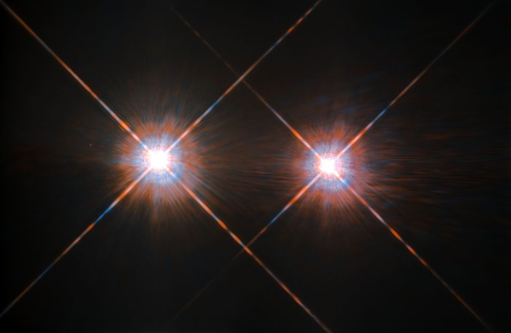

*Hubble image of Alpha Centauri A and B*

**| tau Cet |**

|  |  |
| --- | --- |
| **Luminosity** *in Solar Luminosity* | $$0,5 L_{☉}$$ |
| **Surface Temperature** *in Kelvin* | $$5 340 K$$ |
| **Spectral Class** | $$G$$ |
| **Mass** *in Solar Mass* | $$0,8 M_{☉}$$ |
| **Radius** *in Solar Radius* | $$0,8 R_{☉}$$ |
| **Distance** *in Lightyears* | $$11,9 Ly$$ |

Tau Ceti is a comparatively nearby star system, which is very similar to ours. Accordingly, it is repeatedly studied for the search of extraterrestrial intelligence. There are four known Earth-like planets around Tau Ceti, two of which are in the habitable zone.

***Main-Sequence Star*Tau Ceti**

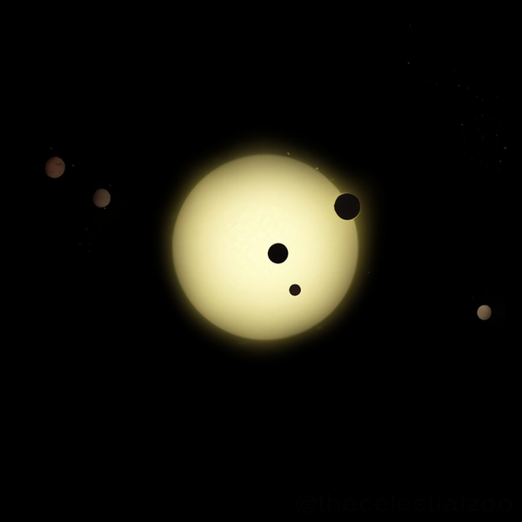

*Illustration of Tau Ceti and his planetary companions*

**| kap Per |**

|  |  |
| --- | --- |
| **Luminosity** *in Solar Luminosity* | $$40 L_{☉}$$ |
| **Surface Temperature** *in Kelvin* | $$4 850 K$$ |
| **Spectral Class** | $$K$$ |
| **Mass** *in Solar Mass* | $$1,5 M_{☉}$$ |
| **Radius** *in Solar Radius* | $$9 R_{☉}$$ |
| **Distance** *in Lightyears* | $$112,7 Ly$$ |

Kappa Persei is a triple star system in the constellation Perseus. The main star is a metal-rich star with helium fusion in its core. Based on measurements of proper motion it can be assumed that Kappa Persei is part of the Hyades star cluster.

***Red Giant*Kappa Persei**

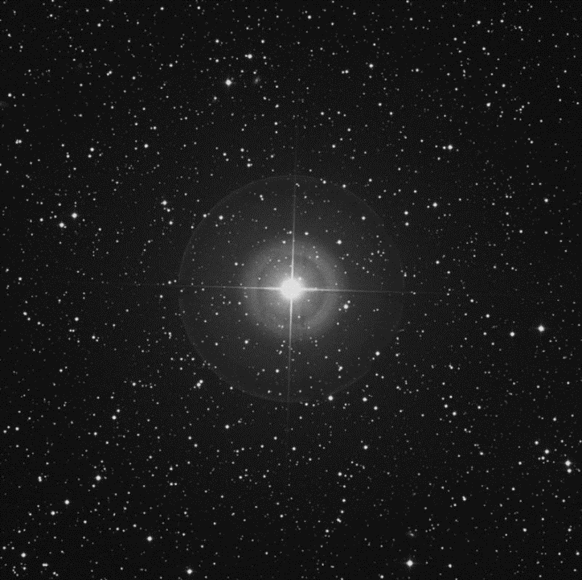

*An image of Kappa Persei with Digital Sky Survey*

**| omi02 Eri |**

|  |  |
| --- | --- |
| **Luminosity** *in Solar Luminosity* | $$0,4 L_{☉}$$ |
| **Surface Temperature** *in Kelvin* | $$5 100 K$$ |
| **Spectral Class** | $$K$$ |
| **Mass** *in Solar Mass* | $$0,9 M_{☉}$$ |
| **Radius** *in Solar Radius* |  |
| **Distance** *in Lightyears* |  |

Eridani is a triple star system 16 light years away. The main star Eridani A is very similar to the Sun in size and age. The second star Eridani B is the first dwarf star discovered (already in 1783). Eridani C is a tiny but highly active star with fluctuating brightness.

***Main-Sequence Star*40 Eridani A**

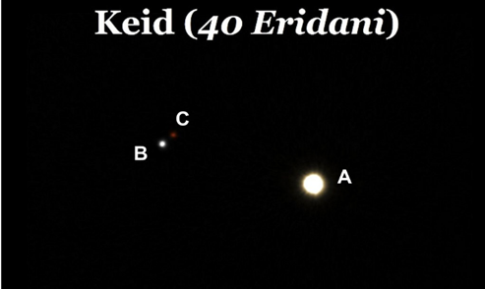

*Telescope image from 40 Eridani A, B & C*

**| 61 Cyg A |**

|  |  |
| --- | --- |
| **Luminosity** *in Solar Luminosity* | $$0,08 L_{☉}$$ |
| **Surface Temperature** *in Kelvin* | $$4 350 K$$ |
| **Spectral Class** | $$K$$ |
| **Mass** *in Solar Mass* | $$0,7 M_{☉}$$ |
| **Radius** *in Solar Radius* | $$0,7 R_{☉}$$ |
| **Distance** *in Lightyears* | $$11,4 Ly$$ |

61 Cygni is a binary star system with two very sunlike stars. The system is relatively close, so that already with an amateur telescope the two single stars can be seen separately.

***Main-Sequence Star*61 Cygni A**

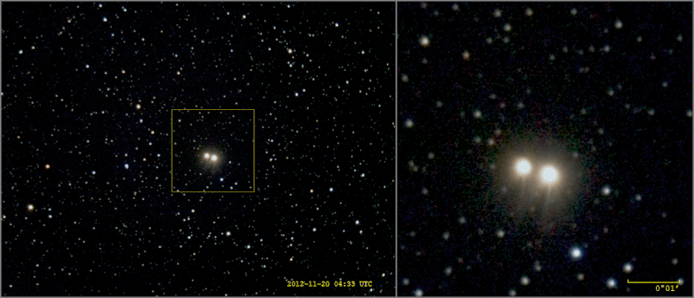

*Telescope image of the binary star 61 Cygni*

**| alf Boo |**

|  |  |
| --- | --- |
| **Luminosity** *in Solar Luminosity* | $$210 L_{☉}$$ |
| **Surface Temperature** *in Kelvin* | $$4 300 K$$ |
| **Spectral Class** | $$K$$ |
| **Mass** *in Solar Mass* | 1,5 $M_{☉}$ |
| **Radius** *in Solar Radius* | $$25,7 R_{☉}$$ |
| **Distance** *in Lightyears* | $$36,7 Ly$$ |

Arcturus is the main star of the constellation Boötes, the brightest star in the northern sky and a Red Giant. Arcturus can be seen from all continents and was the first star observed with a telescope.

***Red Giant*Arcturus**

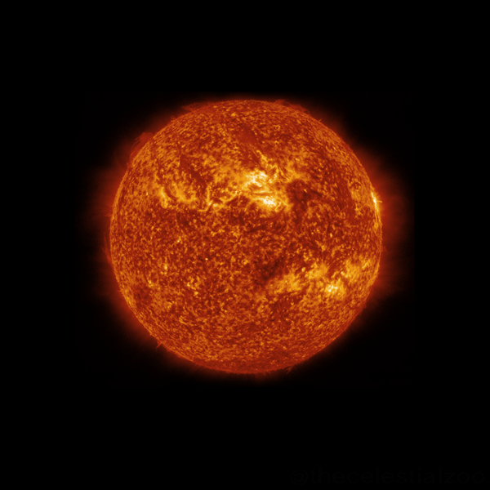

*Artistic illustration of the Arcturus*

**| alf Ori |**

|  |  |
| --- | --- |
| **Luminosity** *in Solar Luminosity* | $$55 000 L_{☉}$$ |
| **Surface Temperature** *in Kelvin* | $$3 600 K$$ |
| **Spectral Class** | $$M$$ |
| **Mass** *in Solar Mass* | $$17 M_{☉}$$ |
| **Radius** *in Solar Radius* | $$760 R_{☉}$$ |
| **Distance** *in Lightyears* | $$550 Ly$$ |

Betelgeuse is a Red Supergiant, into which the Sun would fit about 0.5 billion times. Due to its dimensions, it is one of the few stars visible from Earth as an extended surface with the appropriate telescope technology.

***Red Supergiant***

**Betelgeuse**



*Betelgeuse (left) in front of an emission nebula*

**| omi02 Eri |**

|  |  |
| --- | --- |
| **Luminosity** *in Solar Luminosity* | $$0,022 L_{☉}$$ |
| **Surface Temperature** *in Kelvin* | $$3 500 K$$ |
| **Spectral Class** | $$M$$ |
| **Mass** *in Solar Mass* | $$0,2 M_{☉}$$ |
| **Radius** *in Solar Radius* |  |
| **Distance** *in Lightyears* |  |

Eridani is a triple star system 16 light years away. The main star Eridani A is very similar to the Sun in size and age. The second star Eridani B is the first dwarf star discovered (already in 1783). Eridani C is a tiny but highly active star with fluctuating brightness.

***Main-Sequence Star*40 Eridani C**



*Telescope image from 40 Eridani A, B & C*

**| gam Cru |**

|  |  |
| --- | --- |
| **Luminosity** *in Solar Luminosity* | $$1 500 L_{☉}$$ |
| **Surface Temperature** *in Kelvin* | $$3 400 K$$ |
| **Spectral Class** | $$K$$ |
| **Mass** *in Solar Mass* | $$3 M_{☉}$$ |
| **Radius** *in Solar Radius* | $$110 R_{☉}$$ |
| **Distance** *in Lightyears* | $$88,6 Ly$$ |

Gacrux is visible only from the southern hemisphere, but there it is part of one of the most important constellations for orientation in the sky, the Southern Cross. It is a Red Giant with 110 times the radius of the Sun and has a striking irregular fluctuating brightness.

***Red Giant*Gacrux**

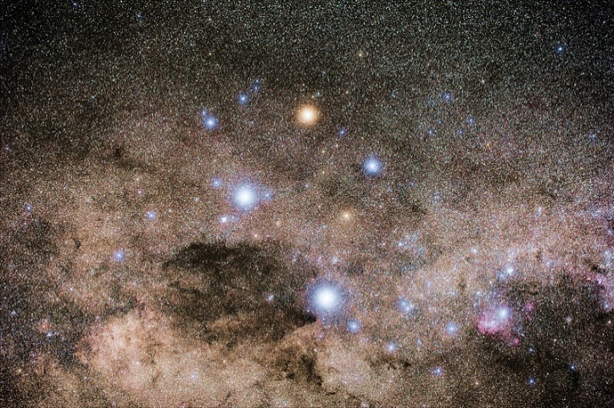

*The Southern Cross, with Gacrux at the top*

**| alf Cen C |**

|  |  |
| --- | --- |
| **Luminosity** *in Solar Luminosity* | $$0,0001 L_{☉}$$ |
| **Surface Temperature** *in Kelvin* | $$3 050 K$$ |
| **Spectral Class** | $$M$$ |
| **Mass** *in Solar Mass* | $$0,12 M_{☉}$$ |
| **Radius** *in Solar Radius* | $$0,15 R_{☉}$$ |
| **Distance** *in Lightyears* | $$4,2 Ly$$ |

Proxima Centauri is a red dwarf orbiting the binary star system Alpha Centauri. For one orbit it needs about 600 000 years. It is the central star of a planetary system. In 2022 the third planet orbiting Proxima Centauri was discovered.

***Red Dwarf***

**Proxima Centauri**

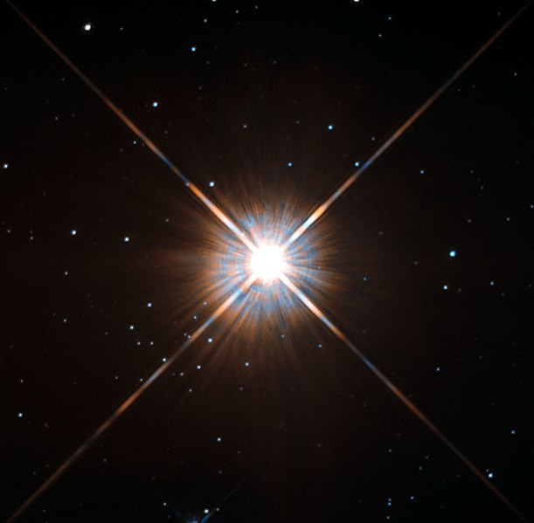

*Hubble image of Proxima Centauri*

**| BD+05 1668 |**

|  |  |
| --- | --- |
| **Luminosity** *in Solar Luminosity* | $$0,003 L_{☉}$$ |
| **Surface Temperature** *in Kelvin* | $$3 200 K$$ |
| **Spectral Class** | $$M$$ |
| **Mass** *in Solar Mass* | $$0,3 M_{☉}$$ |
| **Radius** *in Solar Radius* | $$0,3 R_{☉}$$ |
| **Distance** *in Lightyears* | $$12,3 Ly$$ |

Luyten's star is a red dwarf in the Canis Minor constellation. It was discovered in 1935 by astronomer Willem Luyten, who noticed the strikingly high speed of its proper motion. The star system has an Earth-like exoplanet in the habitable zone and could become a target for the search for extraterrestrial life in the future.

***Red Dwarf***

**Luyten‘s Star**

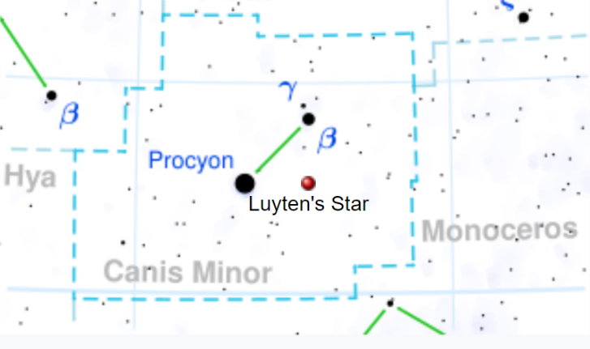

*The position of Luyten's star in the Canis Minor*

**| 119 Tau |**

|  |  |
| --- | --- |
| **Luminosity** *in Solar Luminosity* | $$42 000 L_{☉}$$ |
| **Surface Temperature** *in Kelvin* | $$3 400 K$$ |
| **Spectral Class** | $$M$$ |
| **Mass** *in Solar Mass* | $$12-15 M_{☉}$$ |
| **Radius** *in Solar Radius* | $$600 R_{☉}$$ |
| **Distance** *in Lightyears* | $$600 Ly$$ |

119 Tauri or CE Tauri is just visible with the naked eye under good conditions. Due to its very low surface temperature, it has a striking red color and is therefore also called ruby star.

***Red Supergiant***

**119 Tauri**

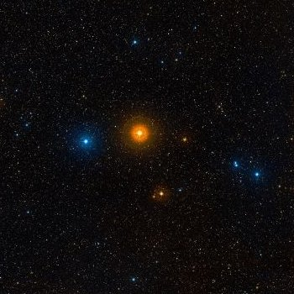

*119 Tauri stands out clearly against the starry sky in terms of color*

**| alf Sco |**

|  |  |
| --- | --- |
| **Luminosity** *in Solar Luminosity* | $$65 000 L_{☉}$$ |
| **Surface Temperature** *in Kelvin* | $$3 500 K$$ |
| **Spectral Class** | $$M$$ |
| **Mass** *in Solar Mass* | $$12 M_{☉}$$ |
| **Radius** *in Solar Radius* | $$700 R_{☉}$$ |
| **Distance** *in Lightyears* | $$600 Ly$$ |

The name Antares comes from the Greek god of war Ares (in Roman Mars) and means something like rival to-Ares. This comes from the fact that Antares seems confusingly similar to Mars in the night sky. It has the same color and brightness (despite its enormous distance) and is also visible near the ecliptic.

***Red Supergiant***

**Antares**

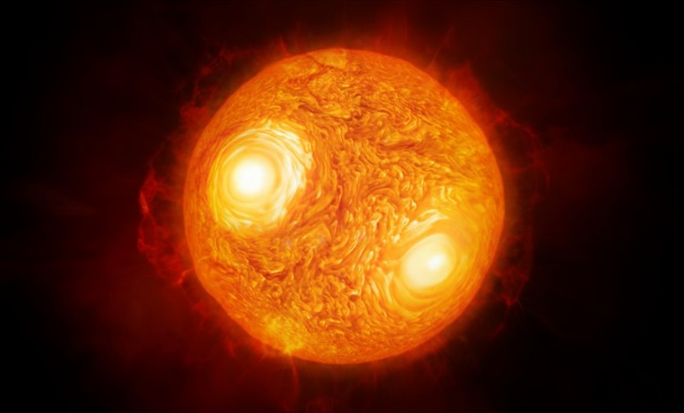

*Artistically post-processed close up of Antares*